AI Tool Kit: Integrated AI Platform for Document, Text, and Speech Processing
Aryan Patel, Bansari Shah, Laxmi Prasanna, Pratham Patel, Vivek Pitroda
Seidenberg School of Computer Science and Information Systems, Pace University
New York, United States
Abstract— AI Tool Kit is an integrated AI-powered web application designed to reduce manual effort in common academic and professional workflows. The system combines text translation, content summarization, PDF-to-flashcard generation, live voice translation, and text-to-speech output in a unified React-based interface. The work uses a modular client-server design in which the user interface handles interaction and file input, backend APIs process requests, and AI services perform language, document, and speech operations. This paper describes the problem context, system architecture, functional modules, deployment approach, security considerations, testing strategy, observed utility, limitations, and future improvements. The implementation emphasizes accessibility, usability, responsive delivery, and repeatable deployment guidance for Windows, macOS, and Linux environments.
Keywords— AI web application, document processing, text summarization, language translation, speech translation, flashcard generation, React, deployment manual

I. INTRODUCTION
AI systems are increasingly used to support reading, writing, communication, and study preparation. However, users often move between separate tools for translation, summarization, document review, and speech conversion. This fragmented workflow increases effort and can make repeated academic or workplace tasks slower than necessary. AI Tool Kit addresses this issue by combining multiple AI-assisted services into one web-based environment.
The current work focuses on a unified application that supports intelligent document processing, text analysis, and speech-based interaction. The application enables users to translate text, summarize content, create study flashcards from PDF materials, and perform speech-related translation tasks. Its purpose is to improve productivity and accessibility through a scalable client-server architecture and a browser-based interface that can be used on common screen sizes [1], [2].
This paper is written as a technical summary and deployment-oriented reference. It is intended for instructors, reviewers, developers, system administrators, and IT personnel who need to understand the design, reproduce the deployment, and evaluate the usefulness of the system.
A. Contributions
- A unified AI workflow that connects text, document, and speech features in one interface.
- A modular architecture separating frontend rendering, backend APIs, and AI service integrations.
- A deployment manual covering prerequisites, configuration, platform-specific setup, testing, and troubleshooting.
- A rubric-aligned security and usability discussion focused on browser compatibility, responsive behavior, private data handling, and repeatable installation.
II. RELATED WORK AND BACKGROUND
Modern web applications often use component-based frontend frameworks to build interactive interfaces. React supports interface development through reusable components, state management patterns, and declarative rendering [6]. Create React App and related tooling provide scripts for local development, testing, and production builds [3]. These tools are appropriate for a capstone-style web application because they simplify initial setup while still supporting production bundling.
Backend services are commonly exposed through REST APIs that separate user-facing interface logic from processing logic. FastAPI is a Python web framework used to create APIs with automatic documentation support and data validation, which makes it suitable for AI-service endpoints [4]. Node.js provides a JavaScript runtime for tooling workflows and is frequently used with npm for dependency installation and script execution [5].
The relevance of this work is in the integration layer. Instead of studying one isolated AI feature, the system organizes multiple AI capabilities around a single user workflow. This improves practical utility by reducing tool switching and by presenting outputs in formats that are useful for study, accessibility, and professional review.
III. SYSTEM DESIGN AND METHODOLOGY
A. Architecture Overview
The application follows a modular client-server architecture. At a high level, the flow is User Input -> Frontend Interface -> Backend APIs -> AI Services -> Processed Output [2]. This pattern supports maintainability because each layer has a clear responsibility: the frontend collects inputs and displays outputs, the backend coordinates processing, and AI services perform specialized tasks.
User Input
↓
React Frontend UI
↓
Backend API Layer
↓
AI Service Modules
↓
Processed Results
Fig. 1. High-level AI Tool Kit processing flow.
As shown in Fig. 1, the design keeps user interaction separate from processing services. This separation is important for scalability: additional AI functions can be added by creating new API routes and frontend components without rewriting the complete application.
B. Frontend Layer
The frontend is responsible for user input, responsive rendering, file upload handling, navigation, animation, and result presentation. The repository identifies React, CSS, HTML, and JavaScript as the main implementation languages, and the package configuration includes React, React DOM, React Router, Recharts, testing libraries, and web-vitals dependencies [7]. The interface is intended to support desktop, tablet, and mobile layouts to satisfy deployment and usability expectations.
C. Backend and AI Service Layer
The wiki describes backend APIs that process text, documents, and audio and integrate with AI services [2]. The technical stack lists Node.js, Python with FastAPI, REST APIs, translation services, summarization models, speech-to-text, and text-to-speech services [8]. In this design, the backend works as an orchestration layer that validates requests, forwards them to the correct AI service, handles errors, and returns structured responses to the frontend.
D. Core Functional Modules
The major functional modules are summarized in Table I. Each module is designed around a specific user need while sharing the same application shell, configuration assumptions, and deployment process.
TABLE I
Core Functional Modules
Module | Main Function
Text Translator | Translates user text between selected languages.
Text Summarizer | Generates short, medium, or detailed summaries from provided content.
PDF Flashcards | Converts study material into question-answer review cards.
Live Voice Translator | Combines speech input, translation, and spoken or written output.
Text-to-Speech | Generates audio output from written text for accessibility or narration.

IV. DEPLOYMENT MANUAL
A. Audience and Scope
The deployment documentation is intended for system administrators, IT personnel, instructors, reviewers, and developers who need to install, run, test, or evaluate the release. The guidance assumes basic command-line experience and access to the repository. The current public repository contains a React-based frontend application and npm scripts for development, testing, and production builds [7]. Where backend services are used, API endpoints and keys should be configured through environment variables rather than hardcoded in source files.
B. Prerequisites
- Git for cloning the repository.
- Node.js and npm for installing frontend dependencies and running scripts defined in package.json [5], [7].
- A modern browser such as Chrome, Firefox, Safari, or Edge for local testing.
- Optional backend runtime: Python 3.10+ with FastAPI/Uvicorn if backend API services are deployed separately [4].
- API credentials for external AI, translation, speech-to-text, or text-to-speech services, if those services are enabled.
C. Windows Deployment Steps
git clone https://github.com/aryan1901/AI-Terminators.git
cd AI-Terminators
npm install
npm start
After running npm start, open http://localhost:3000 in a browser. If PowerShell blocks scripts, run the terminal as an administrator or use a shell configuration approved by the organization. For production testing, run npm run build and serve the generated build directory using a static hosting service.
D. macOS Deployment Steps
git clone https://github.com/aryan1901/AI-Terminators.git
cd AI-Terminators
npm install
npm start
If Node.js is not installed, install it through the official installer or a package manager approved by the user. Then run the commands above and test the application in a browser at http://localhost:3000.
E. Linux Deployment Steps
git clone https://github.com/aryan1901/AI-Terminators.git
cd AI-Terminators
npm install
npm start
On Linux distributions, administrators should confirm that node and npm are available in the path. For production delivery, run npm run build and deploy the build directory behind an HTTPS-enabled web server or static hosting provider.
F. Configuration
Configuration should be stored in environment files or secure deployment settings. Example variables include REACT_APP_API_BASE_URL for backend API routing and service-specific keys for translation, summarization, speech-to-text, and text-to-speech. Secret keys must not be committed to the repository. In a browser application, sensitive keys should be kept on the server side and accessed through backend routes.
REACT_APP_API_BASE_URL=http://localhost:8000
AI_TRANSLATION_PROVIDER=provider-name
AI_SPEECH_PROVIDER=provider-name
G. Backend Deployment Pattern
If a FastAPI backend is used, the backend can be deployed as a separate service. A typical local execution pattern is shown below. The exact directory and module names should match the implementation used by the team.
python -m venv .venv
source .venv/bin/activate
pip install -r requirements.txt
uvicorn main:app --host 0.0.0.0 --port 8000 --reload
V. TESTING, SECURITY, AND TROUBLESHOOTING
A. Testing Strategy
Testing should verify both technical correctness and rubric-aligned usability. The frontend package defines npm test for interactive test execution and npm run build for production bundling [7]. Reviewers should test translation, summarization, PDF upload, flashcard generation, live voice workflow, text-to-speech output, error handling, loading states, and empty-input validation. Responsive behavior should be checked at desktop, tablet, and mobile widths because the release criteria reward applications that run at appropriate screen sizes.
- Run npm test to execute available frontend tests.
- Run npm run build to confirm production bundling succeeds.
- Open the application in multiple browsers and test each module with valid, empty, and invalid inputs.
- Check that private data is not logged in the browser console, stored insecurely, or transmitted without HTTPS in deployed environments.
B. Security Considerations
The deployment should use HTTPS in hosted environments, avoid hardcoded API keys, restrict uploaded file types, limit file size, and validate all user inputs before processing. PDF and audio uploads should be treated as untrusted inputs. If user data is stored, storage must be encrypted or protected through an approved platform. The application should also avoid exposing backend stack traces or provider errors directly to users.
C. Troubleshooting Guide
- npm install fails: confirm Node.js and npm versions, remove a corrupted node_modules folder if needed, and reinstall dependencies.
- Port 3000 is busy: stop the existing process or run the frontend on another approved port.
- API requests fail: verify the API base URL, CORS settings, backend status, and network access.
- AI output is empty: check provider credentials, request payloads, usage limits, and backend logs.
- PDF upload fails: verify file type, file size, parsing dependency, and server upload limits.
- Voice feature fails: check microphone permissions, HTTPS requirements, and speech service configuration.
VI. RESULTS AND UTILITY
The expected result of the system is a single web platform that reduces repetitive manual work across several user tasks. A student can upload study material and generate review flashcards. A professional can summarize long text into structured notes. A multilingual user can translate content or use voice translation for conversational support. A user who prefers audio output can convert text into speech. These outcomes demonstrate utility even when the implementation is evaluated qualitatively rather than through large-scale performance metrics.
The repository organization supports onboarding because the root directory contains a public folder, source folder, README, package-lock file, and package configuration. The package scripts clearly identify development, test, build, and eject commands [7]. This structure helps an outside reviewer locate code and reproduce the frontend release. Additional backend documentation, user stories, and deployment artifacts should be kept in the repository or wiki so that future contributors can understand both implementation and process evidence.
The main technical strength is modularity. New AI functions can be added by extending the frontend navigation, introducing a backend endpoint, and connecting a provider-specific service module. The main limitation is dependency on external AI services, which can introduce latency, usage limits, pricing constraints, and provider-specific errors. Strong error handling and clear user feedback are therefore necessary for production readiness.
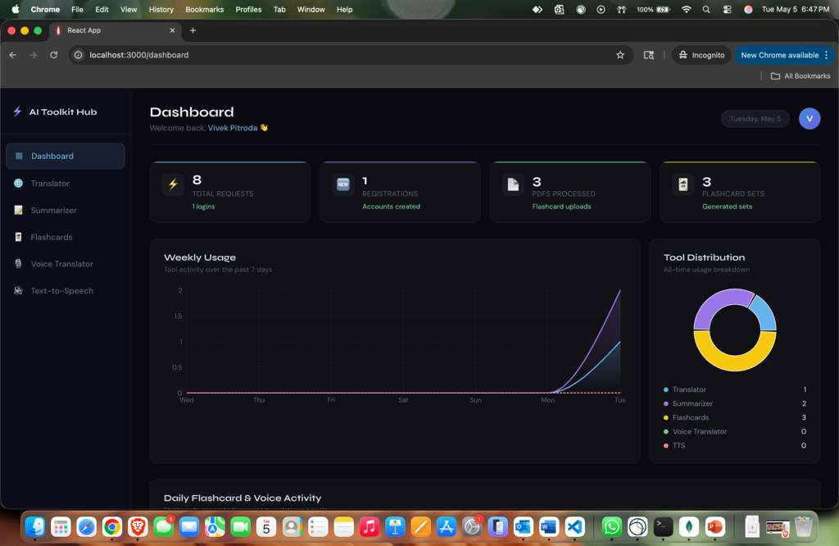
Fig. 6.1. AI Tool Kit — Home Page.
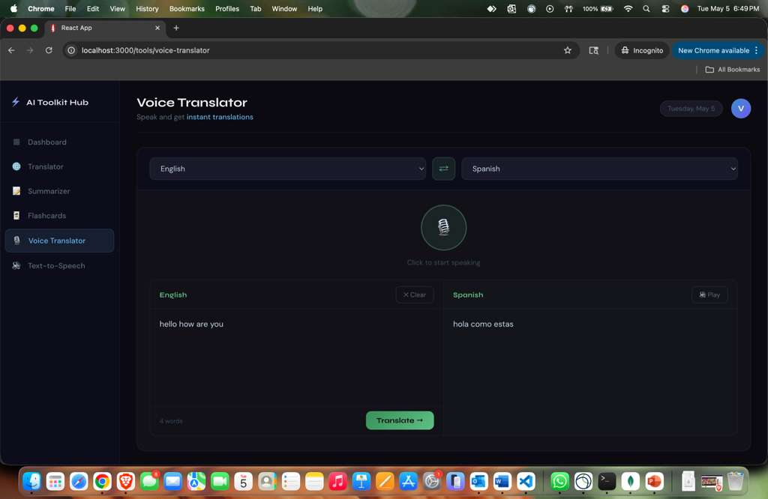
Fig. 6.2. Text Translation Module.
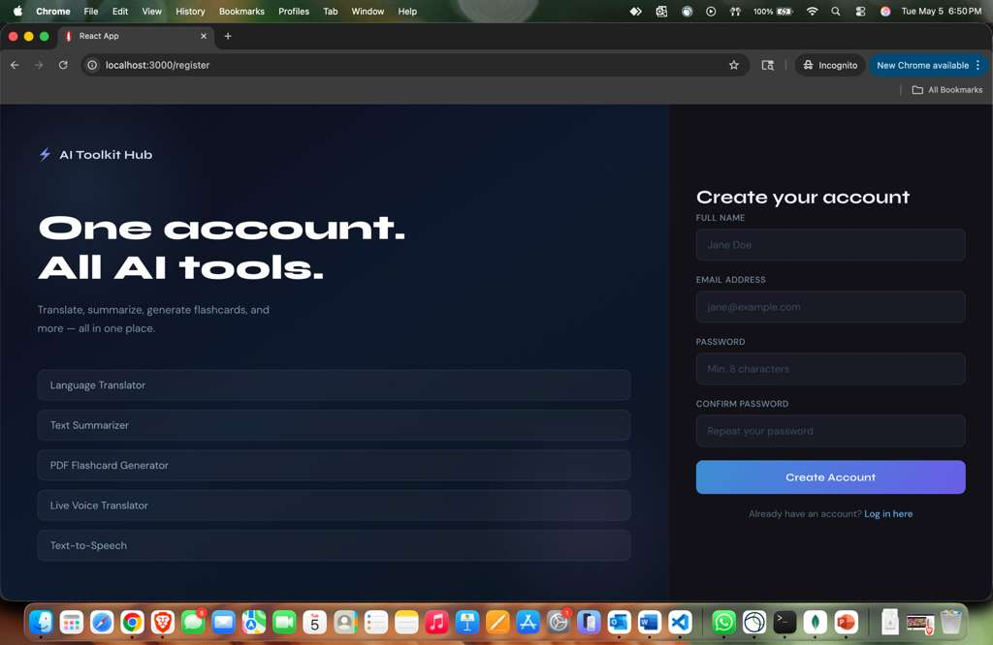
Fig. 6.3. Text Summarization Module.
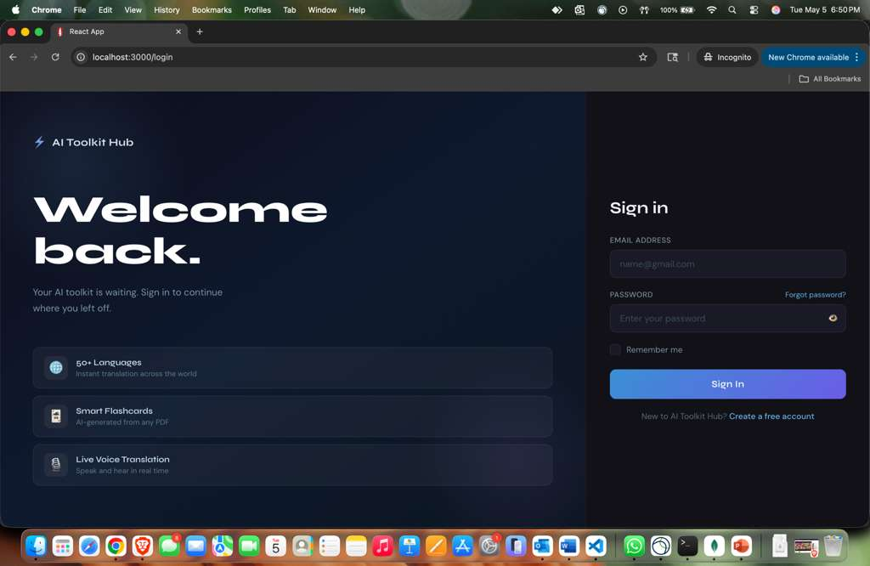
Fig. 6.4. PDF Flashcard Generation.
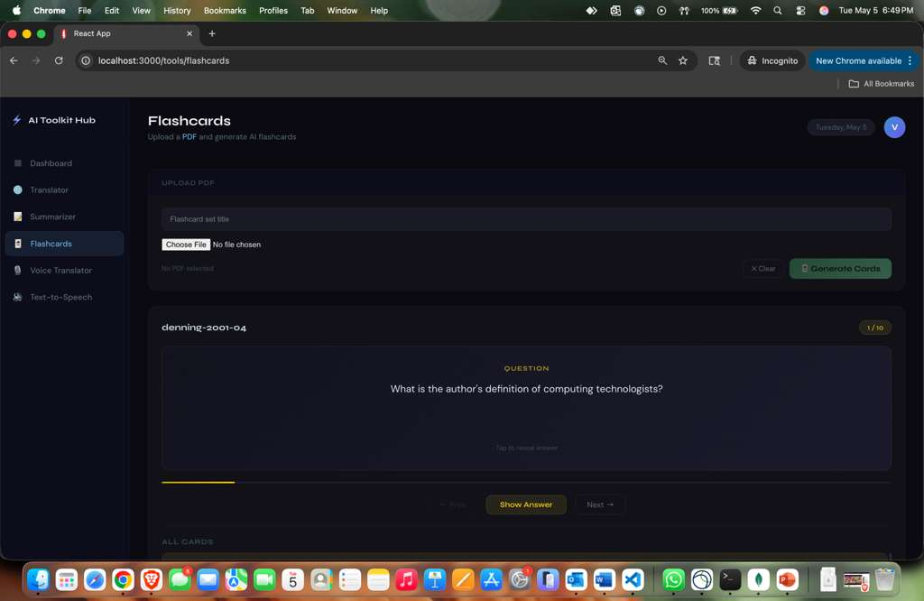
Fig. 6.5. Live Voice Translation Interface.
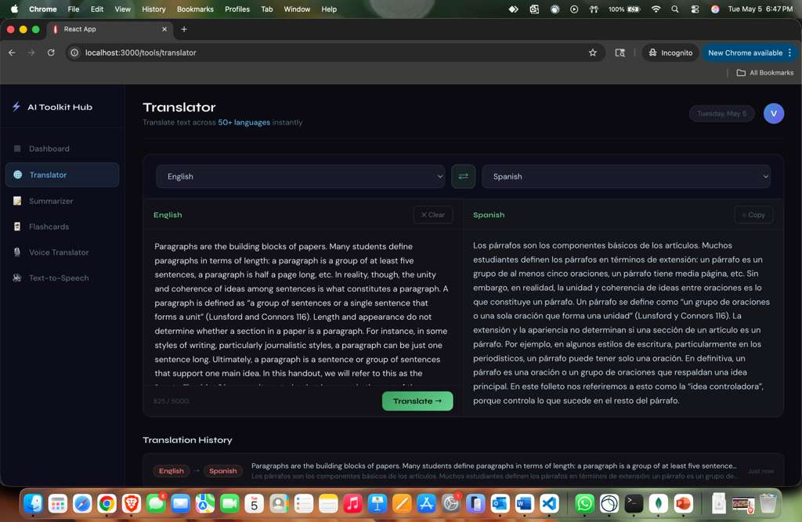
Fig. 6.6. Text-to-Speech Output.
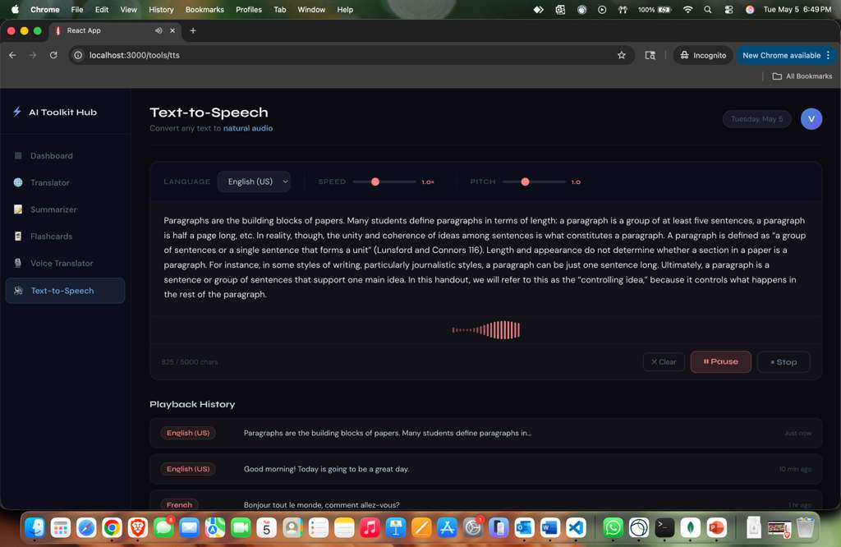
Fig. 6.7. Upload and File Handling.
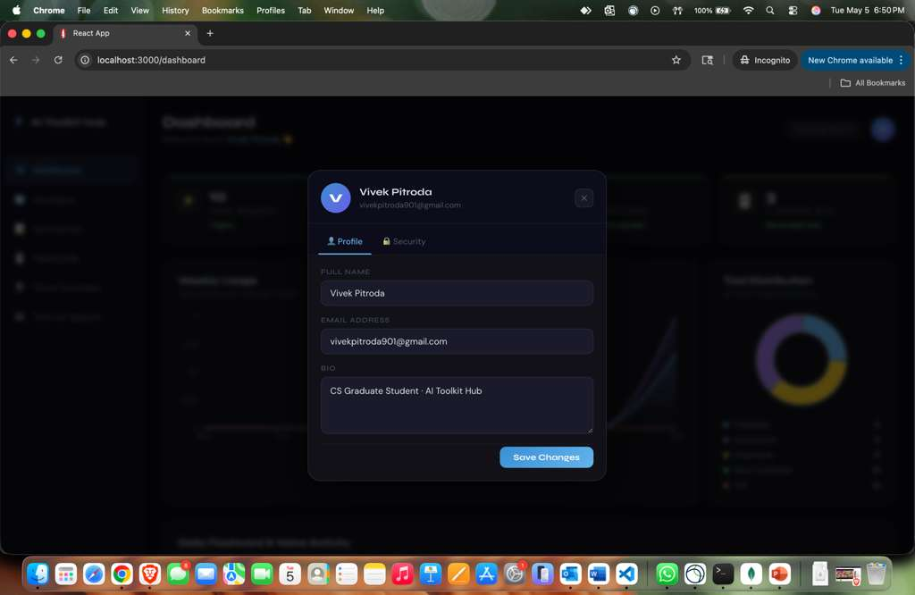
Fig. 6.8. Settings and Configuration.
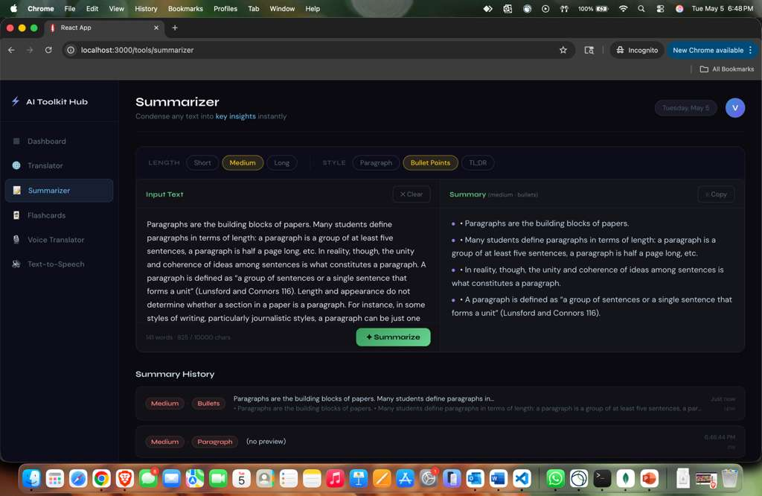
Fig. 6.9. Mobile Responsive View.
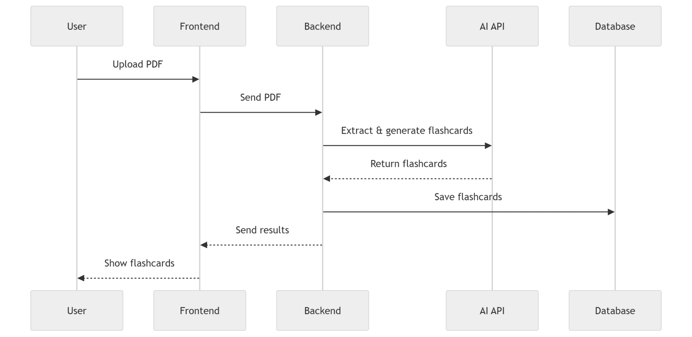
Fig. 6.10. State Diagram.

VII. LIMITATIONS AND FUTURE WORK
The current work should be extended with more formal evaluation. Future testing could measure response time, task completion time, summarization quality, translation accuracy, user satisfaction, and accessibility compliance. Automated tests should be expanded to cover each AI workflow and edge cases such as unsupported PDFs, long documents, poor microphone input, and service failures.
Future enhancements can include authentication, user history management, downloadable result archives, role-based access, analytics dashboards, offline-friendly caching, improved prompt controls, and administrator monitoring. The backend can also be improved with rate limiting, queue-based processing for large files, structured logging, and provider fallback options. These additions would make the system more reliable for real users and easier to maintain after the academic release.
VIII. CONCLUSION
AI Tool Kit demonstrates how multiple AI-assisted functions can be organized into a practical web application. By combining translation, summarization, PDF-based flashcard generation, live voice translation, and text-to-speech, the system reduces tool switching and supports productivity, accessibility, and learning. The modular client-server architecture makes the work maintainable, and the deployment manual provides repeatable instructions for common operating systems. Continued development should focus on security hardening, automated testing, backend documentation, formal usability evaluation, and scalable AI-service orchestration.
ACKNOWLEDGMENT
The authors acknowledge the course guidance and review criteria that shaped the deployment documentation, testing expectations, and technical-paper structure.
REFERENCES
[1] AI-Terminators Wiki, "Home," GitHub, accessed May 2026.
[2] AI-Terminators Wiki, "System Architecture," GitHub, accessed May 2026.
[3] Create React App, "Available Scripts and Deployment Documentation," accessed May 2026.
[4] FastAPI, "FastAPI Documentation," accessed May 2026.
[5] Node.js, "Node.js Documentation," accessed May 2026.
[6] React, "React Documentation," accessed May 2026.
[7] A. Aryan, "AI-Terminators Repository and package.json," GitHub, accessed May 2026.
[8] AI-Terminators Wiki, "Technology Stack," GitHub, accessed May 2026.

